SOBs 4 / 5 / 6 – Combined Mini Project

Automated Irrigation System for Plants

SOB 4: Conditionals & Loops SOB 5: Variables & Datatypes
SOB 6: Code Quality & Style

Project Overview

The Smart Irrigation Monitoring System is a Python-based simulation that automates watering decisions based on soil moisture, rain conditions, and environmental timing.
The project demonstrates the use of variables, loops, conditions, functions, and good programming practices while simulating a realistic agricultural application.

Problem Statement

Traditional irrigation systems may waste water because watering can occur even when the soil is already wet or when rainfall is present. Farmers require a simple automated system capable of making intelligent watering decisions.
The proposed Smart Irrigation Monitoring System solves this problem by checking environmental conditions before activating irrigation.

Program Features

Core Features

- Stores multiple sensor readings using variables and lists.
- Uses conditional statements to decide whether watering is required.
- Uses loops to process multiple readings.
- Simulates watering until moisture reaches a threshold.
- Skips watering during rainfall or high heat periods.
- Generates a summary report.

Programming Concepts Demonstrated

SOB | Demonstration
SOB 4 | if/else conditions, for loops, while loops
SOB 5 | Variables, lists, dictionaries, data storage
SOB 6 | Comments, structure, naming conventions, documentation

Program Flow

The program follows the following sequence:
- Constants and sensor readings are defined.
- The irrigation system function processes all readings.
- Each reading is evaluated using conditional logic.
- Watering is triggered only when required.
- A while loop simulates the watering process.
- The system prints a final summary.

Flowchart Description

The flowchart begins by defining constants and sensor readings. The system then loops through each reading using a for loop. The program checks whether:
- Soil moisture is sufficient.
- Rain is detected.
- Current time is inside the heat restriction window.
If none of these conditions apply, watering begins. The watering process continues until the moisture threshold is reached or the maximum watering time expires.
Finally, the system prints a summary of all processed readings and watering activity.
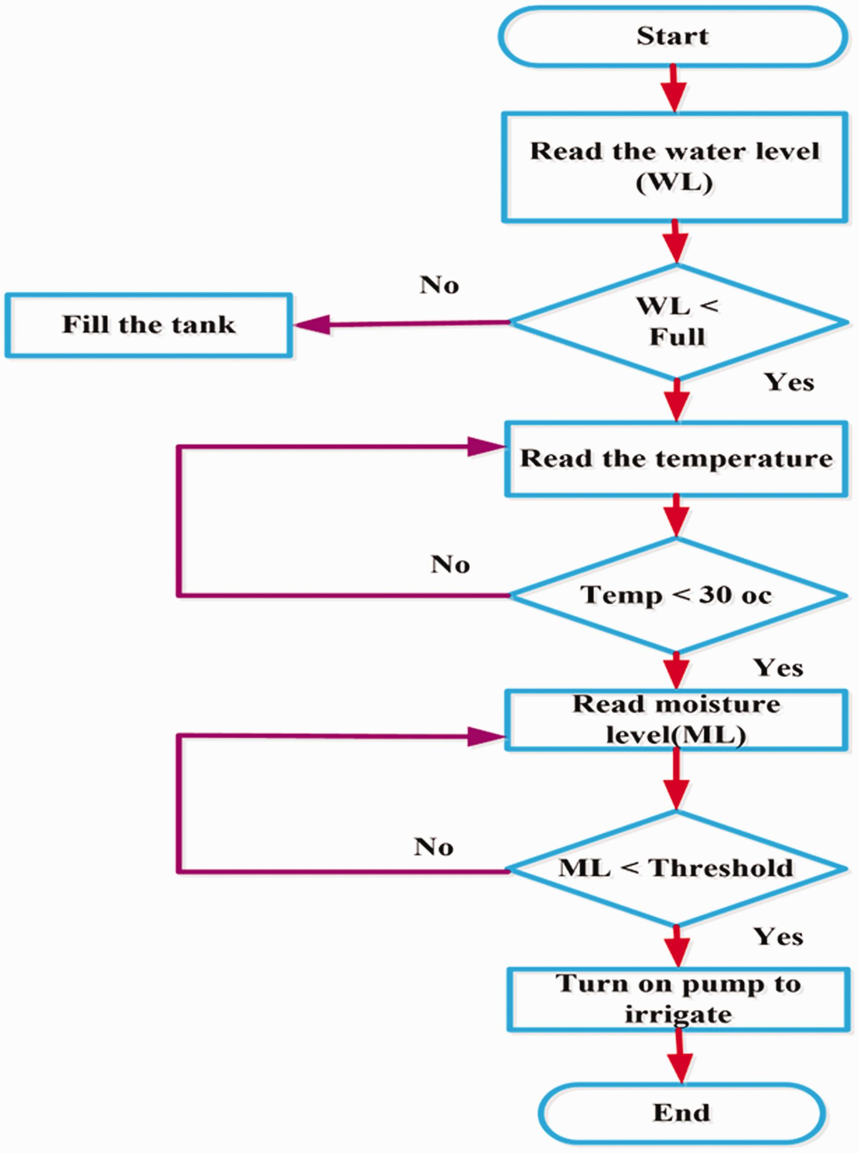

SOB Requirement Mapping

SOB 4 – Conditional and Repetitive Tasks

The program demonstrates:
- if/elif/else statements
- for loops
- while loops

Examples
if moisture >= MOISTURE_THRESHOLD:
for reading in sensor_readings:
while current_moisture < MOISTURE_THRESHOLD:

SOB 5 – Variables and Data Storage

The program uses:
- Variables
- Constants
- Lists
- Dictionaries

Examples
MOISTURE_THRESHOLD = 70
sensor_readings = [...]
moisture = reading["moisture"]

SOB 6 – Good Programming Practice

The program follows good coding standards through:
- Meaningful variable names
- Modular functions
- Comments and documentation
- Consistent formatting
- Proper indentation
- Readable structure

Examples
def evaluate_reading(reading):
# Rain detected

Conclusion

This report demonstrated the difference between sequential programming and finite state machines using a traffic light controller example.
The Smart Irrigation Monitoring System mini project successfully combines SOB 4, SOB 5, and SOB 6 concepts into one practical application. The project demonstrates variables, loops, conditions, functions, and good programming practices while solving a simplified real-world problem related to automated irrigation.
The system is simple, structured, and scalable, making it an appropriate example of beginner-to-intermediate level Python programming.

